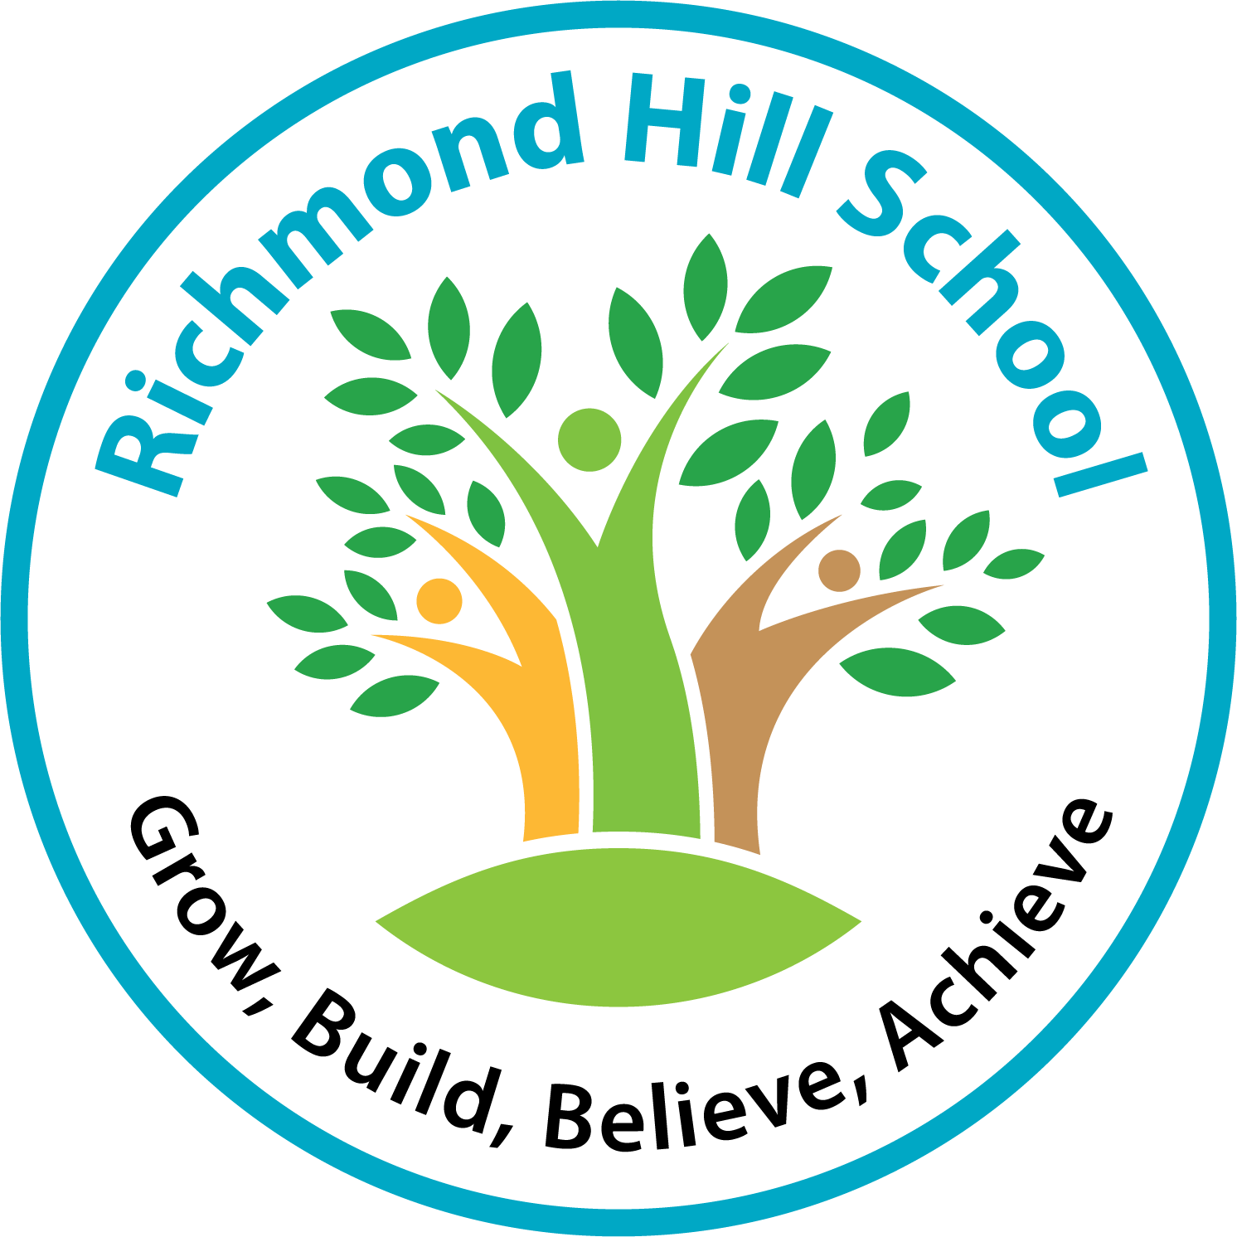

RICHMOND HILL SCHOOL
www.Richmondhillschool.co.uk

West Site: East Site:
Sunridge Avenue, Crawley Green Road
Luton, LU2 7JL Luton, LU2 9TL
Tel: 01582 721019 Tel: 01582 346171
Our School

Richmond Hill is a school for primary aged pupils with severe and complex difficulties which include those on the autism spectrum.

At the present time we have 233 pupils on roll. They are grouped into 28 classes according to age and ability and across our two sites. Years 1 – 3 (14 classes) are at our Crawley Green Road Site and the remaining 14 classes at Sunridge Avenue. Each class has a Teacher and Senior Teaching Assistant with additional Teaching Assistants according to the needs of the pupils. All pupils have a statement or EHC plan and will be working within the P3-P8 range with a few attaining beyond this level. All pupils have communication difficulties and need an augmented approach to aid language acquisition. About 65% of our pupils are on the autistic spectrum and these pupils are fully included in all activities.

Our Curriculum

Our children our taught across three pathways which we call Roots, Shoots and Leaves. Our Root pathway is a communication led curriculum (Connecting and responding) building communication and learning to learn skills for children developmentally between 6-24 months. Our Shoots pathway is a life skills based curriculum growing personal independence and continuing to build communication children are learning to learn and are beginning to build independent learning strategies, early emergent English and Maths skills but still through a creative and cross curricular approach for children between 24-48 months. Our Leaves pathway an adapted National Curriculum with the emphasis on essential skills for independence and life, these children will be developing their independent learning further and continuing to conceptualize their learning through subject specific teaching and learning within a creative cross curricular approach for children approaching National Curriculum level 1.

Our sites (East and West)

The school has extensive and well equipped grounds. West site in Sunridge Avenue is situated in a lovely location surrounded by parkland. The new East site is in an elevated position with views of the airport. We use the local area whenever we can as we believe in the value of education beyond the classroom. We are fortunate in having two minibuses and put these to full use with trips and visits for enhancing and supporting the curriculum.

Both locations have a large and spacious building and have the facilities of a soft play room, light sensory room, library, quiet room, drama room, music room, an ICT suite and personal care rooms. We have a variety of different outdoor play areas with a wide range of excellent equipment.

The school is extremely well resourced with high quality equipment and a high adult pupil ratio and good administrative support. We have over 100 teaching assistants whose role it is to support the pupils within the class. We view the whole day as a learning opportunity and support staff assist their classes in the dining hall & playground. In addition we have specialist teaching assistants for; ICT, PE, Gardening, who deliver learning opportunities in their particular area of expertise.

We have 2 full time Family Workers who work with parents on family training, assisting with Health & Social care matters. This allows the teaching staff to be fully focused on their work in the classroom.

The school has an excellent reputation, locally and nationally.
We have achieved many accredited awards in recent years; Eco Schools, Green Flag, ICT Mark, 3rd Millennium, and Investors in Families,

Our vision statement underpins all our work in the school ‘To grow independence, build communication and believe that we can achieve our personal goals’ and we consider everyone; pupils, parents and adults to be learners.

We therefore encourage everyone to take an active part in our extensive, comprehensive and ongoing training. We have a very robust induction programme. We pride ourselves in having a very friendly, fun and supportive environment where everyone likes to come and fulfill their potential.

We are very enthusiastic and creative in delivering an appropriate curriculum to our pupils and consequently the pupils enjoy coming to school and are keen to learn and well behaved.

We are very proud of our Ofsted report in October 2019 that highlighted many great things about our school and our collaborative and galvanized approach. The Ofsted report is available on our school website.

Staff are expected to adhere to all school policies, we have a heightened safeguarding process as our children are especially vulnerable and we expect all staff to have a strong understanding of how to safeguard our children. This is supported by 5 designated safeguarding Leads.
Please see our Safeguarding Children Policy on our website www.Richmondhill.luton.sch.uk

Please see our person specification which highlights the things that we feel are particularly relevant to this post.

Successful applicants must be prepared to work at either site although there will be discussion and due regard given to personal circumstances and skills.

We are very proud of our school and we encourage and welcome visits. Please telephone for an appointment 01582 721019

